
Calculation Policy
Long Term Plan
Maths LTP  26-27 | Autumn 1 | Autumn 2 | Spring 1 | Spring 2 | Summer 1 | Summer 2
N | - Counting  - Comparing  - Measuring  - Subitising  - Counting  - 1:1 correspondence  - Subitising  - 2D and 3D Shapes |  | - Counting  - Partitioning  - Pattern  - Numerals  - More/less comparison  - Sorting  - Measure  - Position  - Routes |  | - Numerals  - Measures  - Sequencing  - More/ less  - Comparing  - Numerals  - Addition  - Shapes
R | Mastering Number  Pupils will build on previous experiences of number from their home and nursery environments and further develop their subitising and counting skills. They will explore the composition of numbers within 5. They will begin to compare sets of objects and use the language of comparison.  Pupils will:  - identify when a set can be subitised and when counting is needed  - subitise different arrangements, both unstructured and structured, including using the Hungarian number frame  - make different arrangements of numbers within 5 and talk about what they can see, to develop their conceptual subitising skills  - spot smaller numbers  Shape Space and Measures - (WRM)  - Talk about measures and patterns  - Circles and triangles  - Shapes with 4 sides |  | Mastering Number  Pupils will continue to develop their subitising and counting skills and explore the composition of numbers within and beyond 5. They will begin to identify when two sets are equal or unequal and connect two equal groups to doubles. They will begin to connect quantities to numerals.  Pupils will:  - continue to develop their subitising skills for numbers within and beyond 5, and increasingly connect quantities to numerals  - begin to identify missing parts for numbers within 5  - explore the structure of the numbers 6 and 7 as ‘5 and a bit’ and connect this to finger patterns and the Hungarian number frame  - focus on equal and unequal groups  Shape Space and Measures - (WRM)  - Mass and Capacity  - Length, Height and Time  - Explore 3D shapes |  | Mastering Number  Pupils will consolidate their counting skills, counting to larger numbers and developing a wider range of counting strategies. They will secure knowledge of number facts through varied practice.  Pupils will:  - continue to develop their counting skills, counting larger sets as well as counting actions and sounds  - explore a range of representations of numbers, including the 10-frame, and see how doubles can be arranged in a 10-frame  - compare quantities and numbers, including sets of objects which have different attributes  - continue to develop a sense of magnitude, e.g. knowing that 8 is quite a lot more than 2, but 4 is only a little bit more than 2  Shape Space and Measures - (WRM)  - Explore 3D shapes  - Manipulate, compose and decompose
Year 1 | Number: Place Value (within 10)  Number: Addition and Subtraction - Number Bonds | Number: Addition and Subtraction (within 10)  Geometry: Shape | Number: Place Value (within 20)  Number: Addition and Subtraction (within 20) | Number: Place Value (within 50)  Measurement: Length and Height  Measurement: Mass and Volume | Number: Multiplication and Division  Number: Fractions  Number: Place Value (within 100) | Geometry: Position and Direction Measurement: Money  Measurement: Time
Year 2 | Number: Place Value  Number: Addition and Subtraction | Number: Addition and Subtraction  Measurement: Money | Number: Multiplication and Division  Geometry: Shape | Measurement: Length and Height  Measurement: Mass, Capacity and Temperature | Number: Fractions  Measurement: Time | Statistics  Geometry: Position and Direction
Year 3 | Number: Place Value  Number: Addition and Subtraction | Number: Addition and Subtraction  Number: Multiplication and Division A | Number: Multiplication and Division B  Measurement: Length and Perimeter | Number: Fractions A  Number: Fractions B | Measurement: Mass and Capacity Measurement: Money  Measurement: Time | Measurement: Time  Geometry: Shape  Statistics
Year 4 | Number: Place Value  Number: Addition and Subtraction | Number: Multiplication and Division A and B combined  Measurement: Area | Measurement: Length and Perimeter  Number: Fractions | Number: Fractions  Number: Decimals A | Number: Decimals B  Measurement: Money  Measurement: Time | Geometry: Shape  Statistics  Geometry: Position and Direction
Year 5 | Number: Place Value  Number: Addition and Subtraction | Number: Multiplication and Division A  Number: Fractions A | Number: Multiplication and Division B  Number: Fractions B  Number: Decimals and Percentages | Number: Decimals and Percentages  Measurement: Perimeter and Area  Statistics | Geometry: Shape  Geometry: Position and Direction | Number: Decimals  Number: Negative Numbers  Measurement: Converting Units  Measurement: Volume
Year 6 | Number: Place Value  Number: Addition, Subtraction, Multiplication and Division | Number: Fractions A and B  Measurement: Converting Units | Number: Decimals  Number: Fractions, Decimals and Percentages | Measurement: Area, Perimeter and Volume  Number: Ratio  Number: Algebra | Statistics  Geometry: Shape  Geometry: Position and Direction | Investigations and consolidation

National curriculum statements – Addition and subtraction
Year 1 | Year 2 | Year 3 | Year 4 | Year 5 | Year 6
- read, write and interpret mathematical statements involving addition (+), subtraction (−) and equals (=) signs  - represent and use number bonds and related subtraction facts within 20  - add and subtract one-digit and two-digit numbers to 20, including 0  - solve one-step problems that involve addition and subtraction, using concrete objects and pictorial representations, and missing number problems such as 7 = ? − 9 | - solve problems with addition and subtraction:  - using concrete objects and pictorial representations, including those involving numbers, quantities and measures  - applying their increasing knowledge of mental and written methods  - recall and use addition and subtraction facts to 20 fluently, and derive and use related facts up to 100  - add and subtract numbers using concrete objects, pictorial representations, and mentally, including:  - a two-digit number and 1s  - a two-digit number and 10s  - 2 two-digit numbers  - adding 3 one-digit numbers  - show that addition of 2 numbers can be done in any order (commutative) and subtraction of 1 number from another cannot  - recognise and use the inverse relationship between addition and subtraction and use this to check calculations and solve missing number problems | - add and subtract numbers mentally, including:  - a three-digit number and 1s  - a three-digit number and 10s  - a three-digit number and 100s  - add and subtract numbers with up to 3 digits, using formal written methods of columnar addition and subtraction  - estimate the answer to a calculation and use inverse operations to check answers  - solve problems, including missing number problems, using number facts, place value, and more complex addition and subtraction | - add and subtract numbers with up to 4 digits using the formal written methods of columnar addition and subtraction where appropriate  - estimate and use inverse operations to check answers to a calculation  - solve addition and subtraction two-step problems in contexts, deciding which operations and methods to use and why | - add and subtract whole numbers with more than 4 digits, including using formal written methods (columnar addition and subtraction)  - add and subtract numbers mentally with increasingly large numbers  - use rounding to check answers to calculations and determine, in the context of a problem, levels of accuracy  - solve addition and subtraction multi-step problems in contexts, deciding which operations and methods to use and why | - solve addition and subtraction multi-step problems in contexts, deciding which operations and methods to use and why  - solve problems involving addition, subtraction, multiplication and division  - use estimation to check answers to calculations and determine, in the context of a problem, an appropriate degree of accuracy

Addition and Subtraction - Vocabulary Progression
Nursery | Reception | Year 1 | Year 2 | Year 3 | Year 4 | Year 5 | Year 6
 | 1 less,  1 more,  add,  add more,  altogether,  now,  part,  take away,  whole | addition,  add together, subtraction/ subtract, difference,  double,  efficient,  equal to,  fact family, greater,  group,  inverse,  less,  minus,  near double, number bond,  plus,  symbol,  systematic,  total,  partition, | calculation,  method,  efficient,  multiple,  one(s),  operation,  related facts, ten(s),  value,  increase,  decrease,  sum,  addend  sum  minuend  subtrahend  regroup, | column addition, column subtraction,  digit,  estimate,  hundred(s),  crossing the 10, crossing the 100 | accurate,  round,  thousand(s) | ten thousand(s),  hundred thousand(s),  million,  approximate,  difference,  strategy | order of operations (BODMAS)

Addition and Subtraction key mathematical resources

- Cubes (arranged into towers of 10)
- Number lines
- Dienes
- Place value grids
- Place value counters
- Tens frames / Five frames
- Double-sided counters
- Part-part-whole models
- Bar models

Addition (addend + addend = sum)
 | Concrete | Pictorial | Abstract
Subitising | Children are instantly able to see how many WITHOUT counting – they recognise patterns/organusation of objects etc.  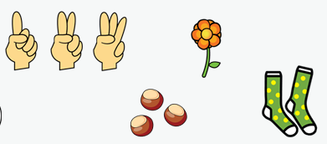 | 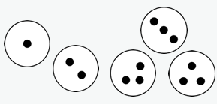  As concrete but within images and representations: | Subitising in the abstract can be visualised as a child or an adult looking at a group of objects and instantly recognising the number of objects without counting them.  e.g. a child might see six dots on a dice and instantly know that there are six without needing to count them.
Conceptually subitise to 5 | Notice the parts that make up the whole in physical objects and resources.  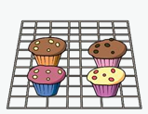  E.g. There are 4. I notice that there is 1 cake has white icing and three have brown icing but altogether there are 4 cakes. 3 and 1 makes 4. | 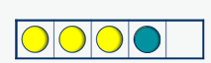  As concrete but with visual representations given/drawn. | Children will be able to explain I know that 5 is made of 1 and 4 or 3 and 2.
Bonds within 10  Y1  Include bonds for each number within 10  Encourage children to notice patterns. | Leading on from sibitising within 5, children should learn the facts as listed to the right. This should be physically taught through concrete objects – towers of 10 etc.  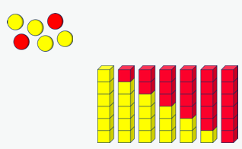  Mastering number specifically teaches this. | 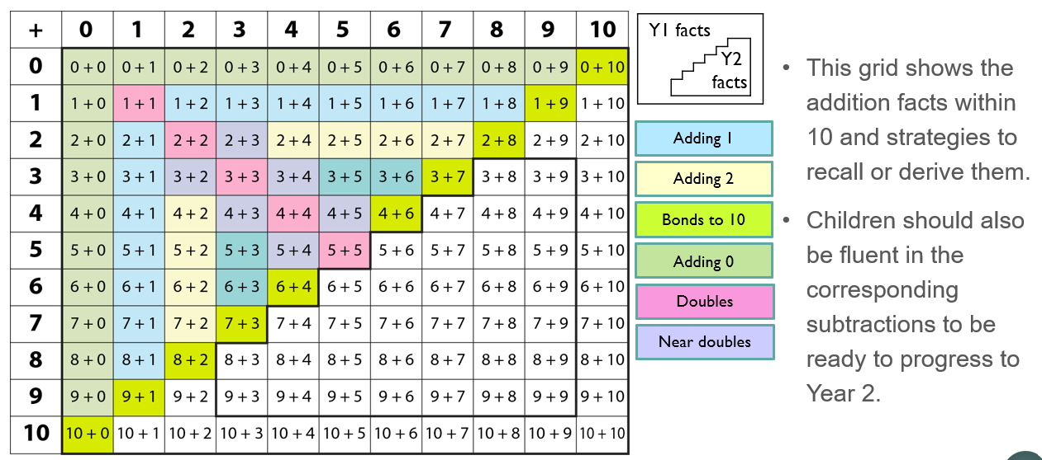
Related facts to 20 | 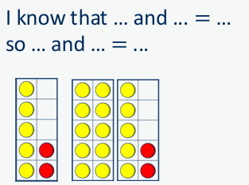  Use tens frames | See YELLOW highlighted facts.  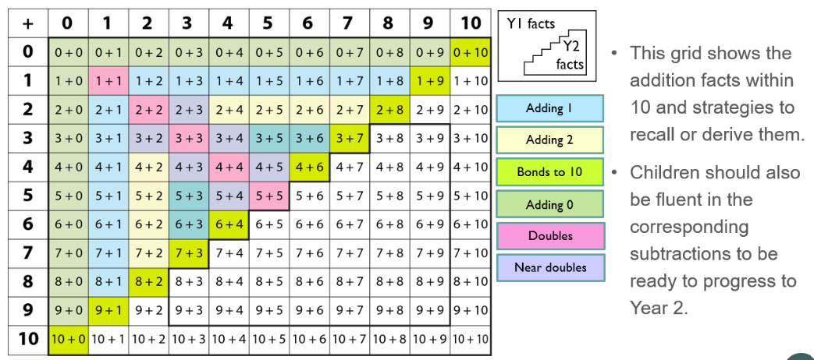  E.g. to calculate 5 + 7  I know that 7 is made of 5 and 2 so I can do 5 + 5 and 2 more is 12.  No counting on or calculation needed.
Add together (aggregation)  Combining two parts to make a whole: part- whole model. | 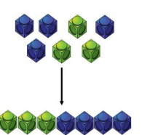  Combine two parts to make a whole using concrete resources (see key resources list). | 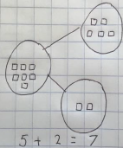  Children draw representations or are given them as pictorial representations. When representing the concrete resources using drawings, circles used for counters, squares for cubes etc.  Note – It is important that children see the part-part whole model in a variety of orientations.  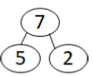  5 is a part, 2 is a part and the whole is 7.  Use part-part whole diagram as shown to move into the abstract. | 5 + 2 = 7  Note – children SHOULD have number fact knowledge that they can draw upon as these numbers become trickier. E.g. I know that 5 + 4 = 9 because 5 + 5 = 10 and I take one off. These are the kinds of discussions to be having with Y1 and Y2.
Add more (augmentation)  Starting at the bigger number and counting on | Using the resource, start with the larger number and then count on to the smaller number 1 by 1 to find the answer.  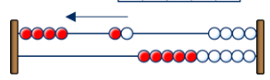  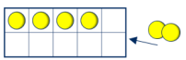  e.g. I start at 4 and then I add another and another. | Children can physically draw number lines as scaffolds - start on the larger number on the number line and count on in ones or in one jump to find the answer. This can move to an empty number line as numbers become larger.  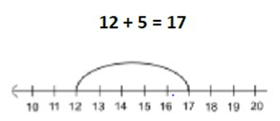  A bar model encourages the children to count on rather than count all. | Children can place the larger number in their head and count on the amount of the smaller number to find the answer.  This will progress to being able to count on the tens and then the ones etc. as numbers increase; this replicates the empty number line.
  ?
  4
Add across a 10  (regrouping to make a 10 and some more) | Using ten frames and counters, create the largest number on the ten frame and add the other number across two ten frames using the other side (different colour).  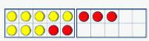  ___ can be partitioned into ____ and ______ | 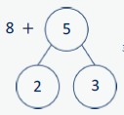  Children to be given pictorial representations of physical resources alongside the pictorial on the left – representing that the second number (8) can be partitioned into 2 and 5. Children to notice this becomes a ten and 3 more. | 8 + 5 = 13  I have 8 sweets, Mrs Mutch gives me 5 more. How many do I have altogether?  Children partition 5 in their head and know that part of that (2) combines with 8 to become 10, and 3 more so 13. They should not need to count at this point.
Add three single digits (make 10 where possible) | 3 + 5 + 7 =  Continue to use tens frames and counters.  A part-whole model alongside this may add additional support.  Where possible, put 3 and 7 together to make 10. Add on 5.  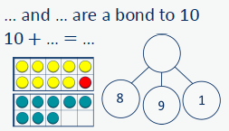 | Pictorial representations alongside abstract support children to visualise the addition of three digits.  They can see the bond to 10 – 7 and 3.  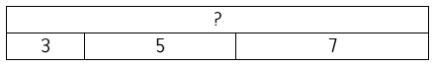 | 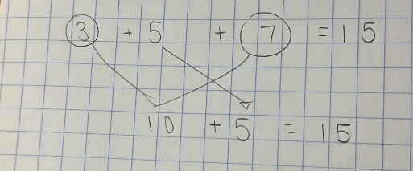  Combine the two numbers that make 10 and then add on the remainder.  This should progress to children having the mental capacity to combine these 3 numbers, using their bonds.
Column method - no regrouping  Y2 – add 2 two-digit numbers  Y3 – add numbers with up to 3 digits  Y4 – add numbers up to 4 digits  Y5 – add numbers with more than 4 digits | Use WRM PV grids with clearly coloured headings.  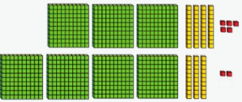  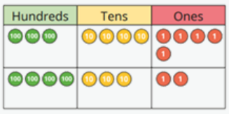  Use dienes initially and progress to PV counters in Y4 as the numbers become ever increasing in size.  - Create both numbers on a place value grid – draw a line between each number to ensure they do not become mixed.  - Add from right to left - ones, tens, hundreds and so on. | 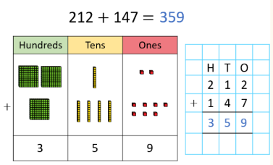  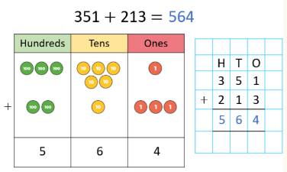  After practically using the dienes or place value counters, children progress to drawing PV grids and counters, as well as being given PV grids alongside the abstract. | 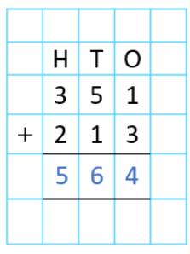  351 + 213 = 564  There is a place for mental methods but always insist on children physically showing their written working – this allows for sense checking.
Add whole numbers – regrouping  Y3 – 3 digit add 3 digit (regrouping across a ten or hundred)  Y4 – 4 digit add 4 digit (regrouping across a ten, hundred or thousand)  Y5 – More than 4 digits  Y6 – Up to 10 million | Use WRM PV grids with clearly coloured headings.  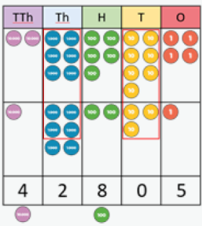  - Using PV counters, create both numbers on a place value grid – draw a line between each number to ensure they do not become mixed.  - Add up the ones and regroup 10 ones for 1 ten or 10 tens for 1 hundred etc.  - Add up the rest of the columns, regroup where necessary.  Progress from 1 regroup, to 2 to more than 2 – plan questions very carefully. The key here is children having the PV knowledge to understand that 10 ones is equivalent to 1 ten etc.  I can regroup 10 ______ for 1 ______ etc. | 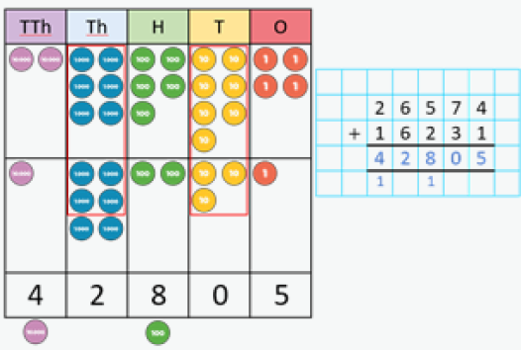  Represent counters and PV grids with pictorial representations. Children to draw into blank grids too. | Once children have an understanding of regrouping, they may be given calculations with more than 4 digits where there is no pictorial representation.  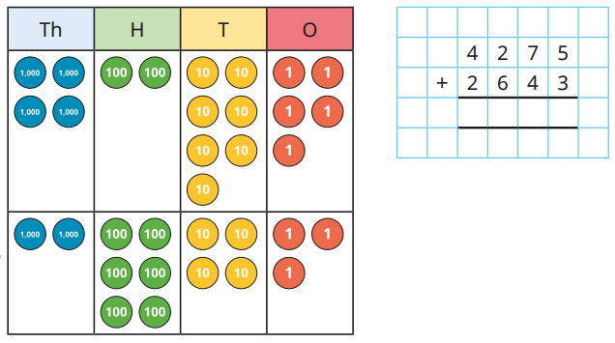  When adding – the regrouped ten, hundred, etc. can be written underneath and crossed out when added back in.
Add decimal with up to 3 decimal places  (2 decimal places for Y5)  (Progress from calculations where there are an equal distribution of digits to calculations where there are not. | 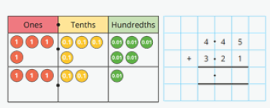  Physically represent with PV counters and a PV grid if children need support in understanding how to line up the digits. | Provide visual representations alongside column methods in order to support children’s understanding.  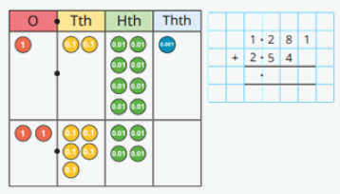  Providing inaccurate representations within ‘dig deeper activities’ provides children with an opportunity to express their secure undertanding of adding decimals. | Ensure PV columns are lined up by using headings above column method.  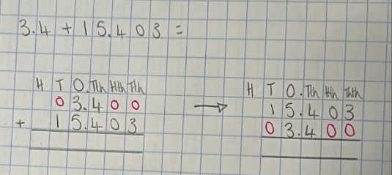  Encourage children to begin with the largest number and replace any ‘missing’ columns with 0s as placeholders.
Subtraction (minuend – subtrahend = difference)
 | Concrete | Pictorial | Abstract
Take away (subtract from any number) | Physically take away and remove objects from a whole (double sided counters, cubes, dienes). | 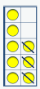  Children draw the concrete resource they are using and cross out the correct amount.  Bar model to represent too; the part-part whole understanding is crucial for understanding of subtraction and supports the understanding of subtraction not being commutative. | Children understand that to take away, we begin with the largest number and take away one part.  They can write subtraction sentences in different wats:  6 − 2 = 4  6 − 4 = 2  4 = 6 − 2  2 = 6 – 4  They can apply it to written problems: Ellie has 4 sweets. She eats who. How many are left?
  8
  3 | ?
Count back | Make the larger number in your subtraction.  Move backwards along a number line/track e.g.  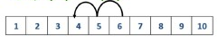  6 – 2 = 4 | Children to represent jumps on a number line.  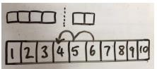  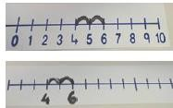  Once children become comfortable with use of a number line, they can draw their own and eventually, use an empty number line. | Encourage children to use and draw empty number lines.  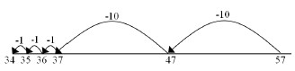  57 – 23 =
Find the difference | 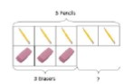  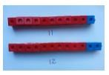  Compare amounts and objects to find the difference. Use cubes to build towards or make bars to find the difference. Use basic bar models with items to find the difference.  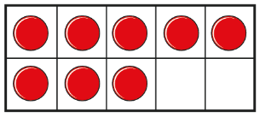  Children to understand/be explicitly taught that the empty squares show the difference in tens frames to 10/20 e.g. the difference between 10 and 8 is 2 etc. | 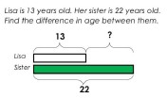  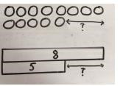  Children are given/draw bar models to represent difference. | Here children know that the difference between 2 and 4 is the same as the difference between 5 and 3 and so on.  In UKS2, they use difference to help them calculate more effectively, instead of replying upon column methods e.g. 3291 – 1999 has the same difference as 3292 – 2000.
Subtract across a 10  From Y2 | One step on from counting back, count back, recognising how to get to the next ten and ‘some more.’  Ten frames and counters alongside part-part whole models will develop this understanding. As numbers increase, a number line can be used as seen prior.  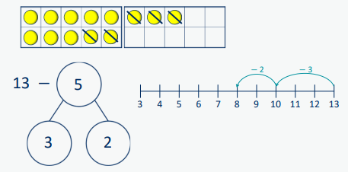 | Children draw or are given visual representations so they can physically see the ten being crossed i.e. crossed out or split into | 23 – 7 =  Children use number bonds and related facts to be able to explain – ‘I partitioned 7 into 3 and 4 so 23 – 2 = 20 and 20 – 4 = 16’
Subtract a 10 and multiples of 10 from any number. | 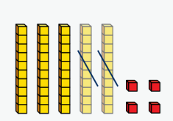  Create the number using dienes and subtract 10 and multiples of 10 from given number.  Ask – what do you notice about the tens column? And the ones column? | Children draw the dienes and cross out the tens.  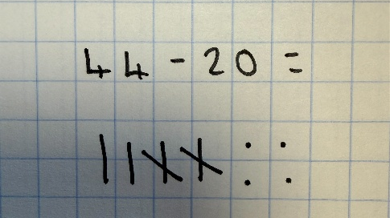 | 23 – 10 =  56 – 20 =  At this stage children should understand that the tens column decreases but the ones column does not. Discussions around this will support understanding. Use questions such as ‘what do you notice?’ ‘What’s the same an what’s different?’
Column method – no regrouping | Use dienes to represent subtraction e.g. 43 – 21 = 22  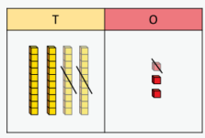  Start by physically creating the number of 43 and taking away the 21 dienes. Discuss this as 1 one and 2 tens. Subtract the one first to replicate the later column.  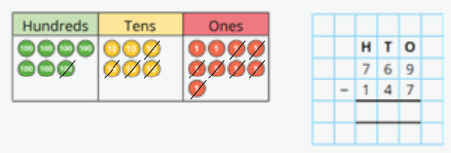  PV counters from Y3 upwards.  Key understanding – no need to make both numbers when subtracting. | 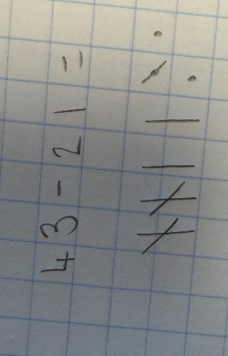  Children pictorially represent their calculations as drawing of dienes and crossing out of the ones being subtracted. | Formal written method can be introduced from Spring term in Y2, as long as children are secure with use of dienes.
Column method – regrouping  Y2 - Begin to regroup 1 ten for 10 ones  Y3 – Formal written method involving up to 2 regroups including 3-digit subtract 2-digit numbers  Y4 – Formal written method with up to 3 regroups. Encourage children to estimate and use inverse operations to check answers to calculations.  Y5/Y6 – 4+ regroups. | 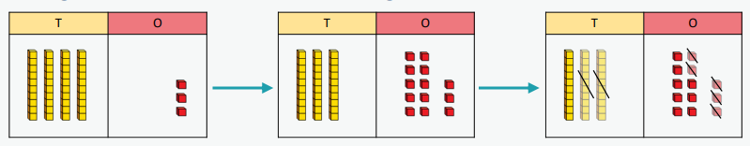  43 – 25 =  Children physically make the number using dienes (Ks1/Y3/Y4) or PV counters. They should physically regroup a ten for ten ones to to understand the regroup process.  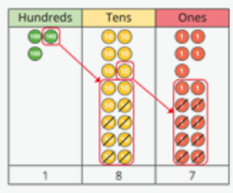  Move into exchanging a hundred for ten tens and so on.  365 – 178 = | 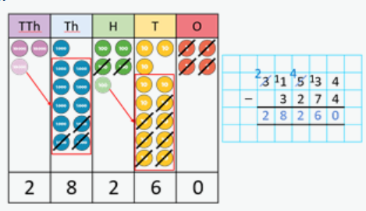  Give children pictorial representations alongside their abstract representations. Encourage them to physically cross out and regroup (draw) a ten thousand for ten thousands etc. | Column method.  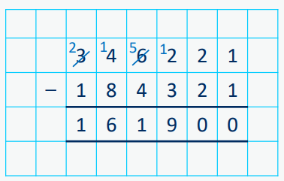
Subtract decimals  Y4 - Subtract decimal numbers in the context of money Emphasis here is on partitioning and use of number lines rather than formal written calculations. | Emphasis here is on partitioning and use of number lines rather than formal written calculations.  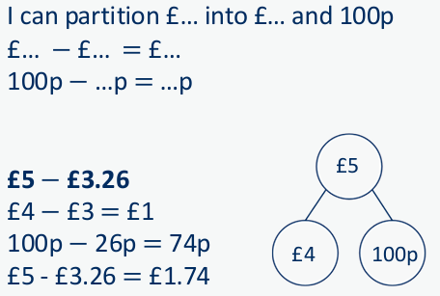 | 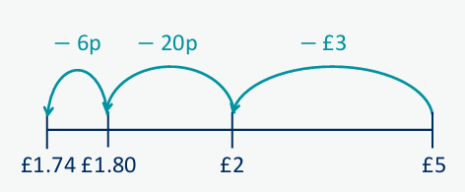  Draw an empty number line and count back, first subtracting pounds and then pence. | Here, children may use written notation to represent mental calculation:  £5 − £3.26  £4 − £3 = £1  100p − 26p = 74p  £5 - £3.26 = £1.74
Subtract decimals  Y5 - subtract decimals with up to 2 decimal places  Progress from the same number of decimal places to a different number of decimal places and from no regroup to regroup. | Use PV counters to represent:  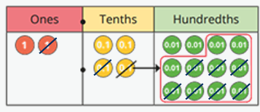  2.42 – 1.17 = | Progress to having images/representations of PV table and counters where children cross out and physically draw the hundredths etc. next to the column method.  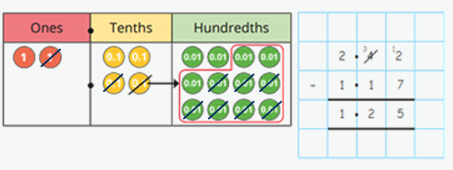 | 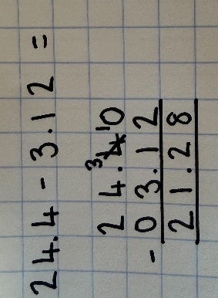  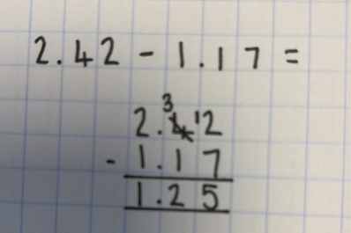  Children set out subtraction in a column and add placeholders when there is an uneven number of places. E.g. the first number is to one decimal place and the second is to two decimal places.
Subtract decimals  Subtract decimals with up to 3 decimal places Progress from the same number of decimal and whole number places to a different number of decimal and whole number places. | PV counters to represent subtracting decimals where there are not an equal number of decimal places  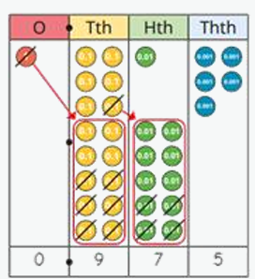  e.g. 1.615 – 0.64 = | 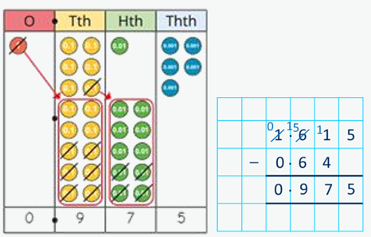  Progress to having images/representations of PV table and counters where children cross out and physically draw the hundredths etc. next to the column method. | Use a placeholder where there are an unequal number of places.  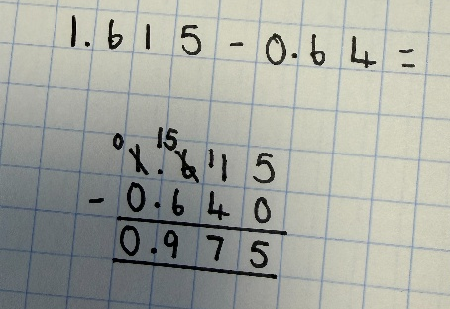

National curriculum statements – Multiplication and Division
Year 1 | Year 2 | Year 3 | Year 4 | Year 5 | Year 6
- solve one-step problems involving multiplication and division, by calculating the answer using concrete objects, pictorial representations and arrays with the support of the teacher  Notes and guidance (non-statutory)  Through grouping and sharing small quantities, pupils begin to understand:  - multiplication and division  - doubling numbers and quantities  - finding simple fractions of objects, numbers and quantities  They make connections between arrays, number patterns, and counting in 2s, 5s and 10s. | - recall and use multiplication and division facts for the 2, 5 and 10 multiplication tables, including recognising odd and even numbers  - calculate mathematical statements for multiplication and division within the multiplication tables and write them using the multiplication (×), division (÷) and equals (=) signs  - show that multiplication of 2 numbers can be done in any order (commutative) and division of 1 number by another cannot  - solve problems involving multiplication and division, using materials, arrays, repeated addition, mental methods, and multiplication and division facts, including problems in contexts | - recall and use multiplication and division facts for the 3, 4 and 8 multiplication tables  - write and calculate mathematical statements for multiplication and division using the multiplication tables that they know, including for two-digit numbers times one-digit numbers, using mental and progressing to formal written methods  - solve problems, including missing number problems, involving multiplication and division, including positive integer scaling problems and correspondence problems in which n objects are connected to m objects | - identify multiples and factors, including finding all factor pairs of a number, and common factors of 2 numbers  - know and use the vocabulary of prime numbers, prime factors and composite (non-prime) numbers  - establish whether a number up to 100 is prime and recall prime numbers up to 19  - multiply numbers up to 4 digits by a one- or two-digit number using a formal written method, including long multiplication for two-digit numbers  - multiply and divide numbers mentally, drawing upon known facts  - divide numbers up to 4 digits by a one-digit number using the formal written method of short division and interpret remainders appropriately for the context  - multiply and divide whole numbers and those involving decimals by 10, 100 and 1,000  - recognise and use square numbers and cube numbers, and the notation for squared (²) and cubed (³)  - solve problems involving multiplication and division, including using their knowledge of factors and multiples, squares and cubes  - solve problems involving addition, subtraction, multiplication and division and a combination of these, including understanding the meaning of the equals sign  - solve problems involving multiplication and division, including scaling by simple fractions and problems involving simple rates | - identify multiples and factors, including finding all factor pairs of a number, and common factors of 2 numbers  - know and use the vocabulary of prime numbers, prime factors and composite (non-prime) numbers  - establish whether a number up to 100 is prime and recall prime numbers up to 19  - multiply numbers up to 4 digits by a one- or two-digit number using a formal written method, including long multiplication for two-digit numbers  - multiply and divide numbers mentally, drawing upon known facts  - divide numbers up to 4 digits by a one-digit number using the formal written method of short division and interpret remainders appropriately for the context  - multiply and divide whole numbers and those involving decimals by 10, 100 and 1,000  - recognise and use square numbers and cube numbers, and the notation for squared (²) and cubed (³)  - solve problems involving multiplication and division, including using their knowledge of factors and multiples, squares and cubes  - solve problems involving addition, subtraction, multiplication and division and a combination of these, including understanding the meaning of the equals sign  - solve problems involving multiplication and division, including scaling by simple fractions and problems involving simple rates | - multiply multi-digit numbers up to 4 digits by a two-digit whole number using the formal written method of long multiplication  - divide numbers up to 4 digits by a two-digit whole number using the formal written method of long division, and interpret remainders as whole number remainders, fractions, or by rounding, as appropriate for the context  - divide numbers up to 4 digits by a two-digit number using the formal written method of short division where appropriate, interpreting remainders according to the context  - perform mental calculations, including with mixed operations and large numbers  - identify common factors, common multiples and prime numbers  - use their knowledge of the order of operations to carry out calculations involving the 4 operations  - solve problems involving addition, subtraction, multiplication and division  - use estimation to check answers to calculations and determine, in the context of a problem, an appropriate degree of accuracy
Multiplication and Division - Vocabulary progression
Nursery | Reception | Year 1 | Year 2 | Year 3 | Year 4 | Year 5 | Year 6
 | double,  equal groups, even,  fair,  grouping,  groups,  odd,  pair,  sharing,  unequal groups | array,  divide  repeated addition, | commutative,  lots of,  multiply,  twice,  times,  times-table,  row,  column,  factor,  product,  dividend,  divisor,  quotient | commutative, inverse,  multiple,  remainder,  scaling | factor pair, inverse,  triple,  efficient | common multiple, common factor, cube number, prime number, square number | composite number, order of operations,

Addition and Subtraction key mathematical resources

- Cubes (arranged into towers of 10)
- Number lines
- Dienes
- Place value grids
- Place value counters
- Tens frames / Five frames
- Double-sided counters
- Part-part-whole models
- Bar models
Multiplication (factor x factor = product)
 | Concrete | Pictorial | Abstract
Doubling | Use practical activities to show how to double a number.    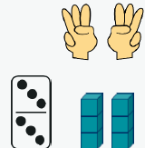 | Draw images to physically show a double. Notice that each part is equal but we count both.  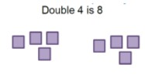 | 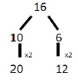  Partition a number and then double each part before recombining it back together.
Counting in multiples of 2s, 5s and 10s  Y1 into Y2 | 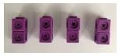  Count in multiples begins by counting concrete objects in equal groups.  Recognise patterns – 2 odds make an even etc. Use numicon to support this.  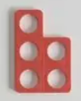  e.g. Five is odd, two fives fit together to make an even number etc. | Use images to continue to support counting in multiples. Counting stick is to be introduced in Y2 - children should be recognising patterns and recognising odds/evens. Patterns are then built upon during this teaching – e.g. two 2s are 3, if I double that, I get four 4s which is 16.  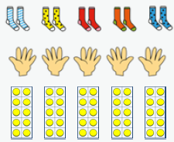  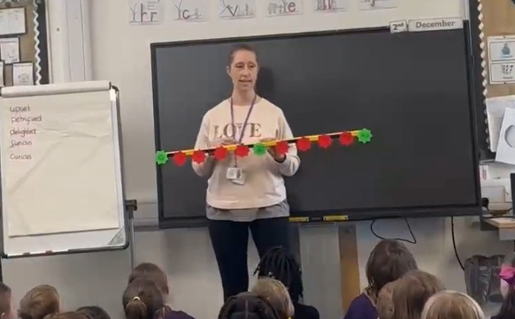 | 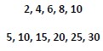  Counting in multiples of a number aloud. Write sequences with multiples of numbers.
Repeated addition  Y1/Y2 | 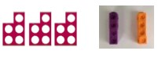  Use key representations and known objects to add equal groups. | 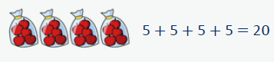  Provide children with images to represent repeated addition, writing out the abstract alongside.  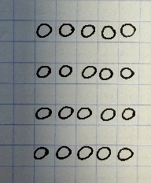  Children can also draw the representation.  E.g. 5 + 5 + 5 + 5 could be represented with 4 columns of 5 counters. | Write addition sentences to describe objects and pictures.  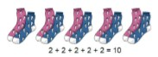
   |  | 10
  2 | 2 | 2 | 2 | 2
Arrays – showing  commutative multiplication  Y2 | Create arrays using double-sided counters to show multiplication sentences. Use these arrays to illustrate commutativity.    Use key vocabulary:  - 3 lots of 5 = 15  - 5 + 5 + 5 = 15  - 5 lots of 3 = 15  - 3 + 3 + 3 + 3 + 3 = 15 | 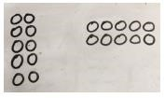  Children should draw arrays in different rotations to find commutative multiplication sentences.  They should circle rows and columns and be taught that circling one way gives one representation, and the other way gives another.  e.g. this shows 5 lots of 3. | 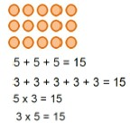  Use arrays to write multiplication sentences and reinforce repeated addition.
Short Multiplication – expanded method.  Progress to this method towards the end of Y3 in prep for Y4. | 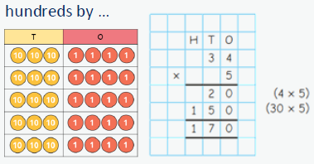  Using dienes/PV counters and a PV chart, physically represent calculations:  34 x 5 = | Give visual representations alongside the abstract method so that children can visibly see that 5 groups of 4 is 20 etc. | Children progress to the expanded formal method of short multiplication.
Short multiplication  Y4 – multiply 2 and 3 digit numbers by 1 digit  Y5/Y6 – multiply numbers up to 4 digits by a one- or two-digit number using a formal written method | Using dienes/PV counters and a PV chart, physically represent calculations:  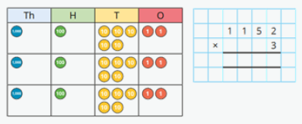  1152 x 3 = | Visual representations alongside the abstract method to support with understanding. | 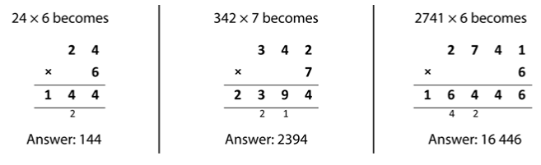  Column methods are used as shown. Cross through the regroup once it has been added in.
Long multiplication – area model  Y5 - multiply numbers up to 4 digits by a one - or two-digit number using a formal written method, including long multiplication for two-digit numbers | 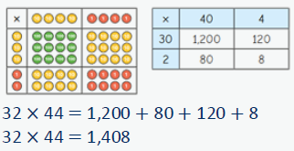  Use PV counters to physically represent the area model. This supports in understanding of the different values which are multiplied together to reach the final whole. | Progress to | 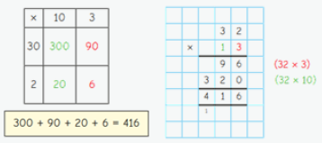  Finally, once children are ready, move to the formal written method.
Long multiplication  Y6 – multiply multi-digit numbers up to 4 digits by a two-digit whole number using the formal written method |  |  | 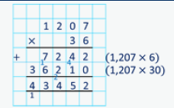  Notice the placement of the regrouping. This is within the next PV column but smaller so that it does not become confused with the actual digit being placed here.
Multiply decimals by whole numbers – Y6 | 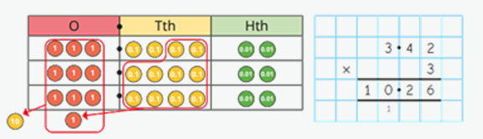  Physically set out the 3 lots of 3.42. Use this to support understanding of 3 lots of 4 tenths becomes one whole and 2 tenths etc. | Visual representations to be given alongside a column method so that children can make the link. Children to draw out and calculate their own columns in their book, however.  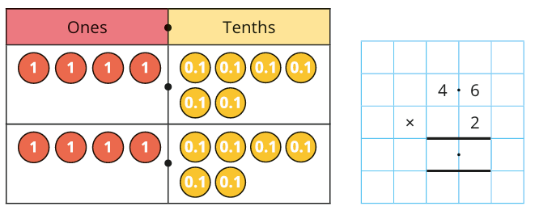 | 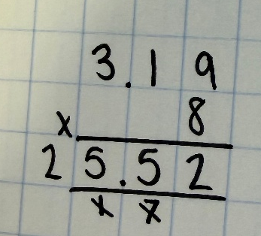  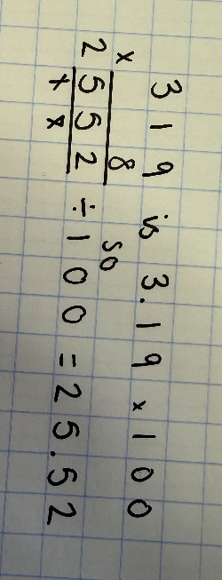  When appropriate, children can use their place value knowledge to make the number being multiplied 10, 100 or 1000 times bigger and then multiply and make the answer 10, 100 or 1000 times smaller. E.g.  Encourage children to write down what they already know.

Division (dividend ÷ divisor = quotient)
 | Concrete | Pictorial | Abstract
Halving | 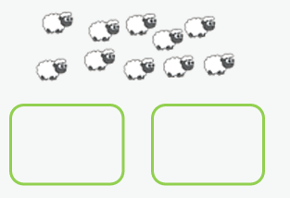  Have an equal amount of items – share them equally into two groups.  10 ÷ 2 = | Children use bar models/ to draw and represent a half.  They notice that each half is equal.  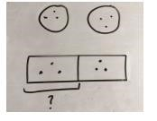  8 ÷ 2 = 4 | 6 ÷ 2 = 3  They notice that each half is equal and two halves make  one whole.
Division by sharing tells us how many are in each group when we know the number of groups. (this stem sentence makes it explicit from grouping)  Y1/Y2  This method is intuitive for children because it mirrors real-life situations like distributing toys or snacks equally. | Children physically share objects (counters or cubes)  e.g. there are 10 squares of chocolate and five people to share them with, how many pieces does each person receive?    ● ● ● ● ● ● ● ● ● ●  ↓  👤 ● ●  👤 ● ●  👤 ● ●  👤 ● ●  👤 ● ●  Note – when numbers become larger – use  dienes/PV counters. | Children use a bar model to draw and share quantities.  This can initially be a given bar model before children move to drawing their own.  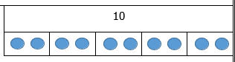  First draw the bar model and put your whole number on the top.  Next, the divisor tells us how many equal groups to make. Split the bottom of the bar by your divisor.  e.g.  For 10 ÷ 5, split the bar into 5 equal parts. Then share the 10 equally between the parts.)  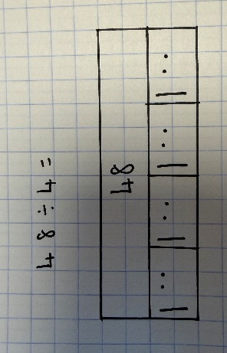  For 48 ÷ 4, split the bar into 4 equal parts. Then share the 48 equally between the parts. | Sharing division: Number of groups known → find the amount in each group.  Example: 10 ÷ 5 = 2 (5 groups, 2 in each group).  I know that 10 sweets shared between 5 people gives them all 2 each.
Division as grouping  (Use arrays to support with this)  Encourage building on sharing knowledge here – what do you notice? Divisor and quotient are swapped but the dividend remains the same. (Sharing asks: "If I have 10 and share it between 5 people, how many does each person get?"  Grouping asks: "If I have 10 and make groups of 2, how many groups can I make?")  So 10 ÷ 2 = 5  and 10 ÷ 5 = 2 | Make equal groups of physical objects and group them.  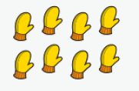  e.g. pair the gloves.  Provide opportunities to make equal groups using cubes and counters. Encourage children to check that each group has the same amount – link to arrays as early as possible.  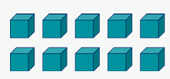   | Draw equal groups and circle them – we are still physically grouping by drawing the circle lines around each group.  10 ÷ 2 = 5 | Division by grouping tells us how many groups can be made when the size of each group is known.  10 ÷ 2 = 5  I know that 10 biscuits grouped into sets of 2 gives 5 groups of 2.  Note – Always link to times tables knowledge.
Division as grouping on an empty number line  Y3  (no remainders and then remainders)  Link to arrays –  e.g. we cannot draw an array of 48, we’ll be here all day,. | 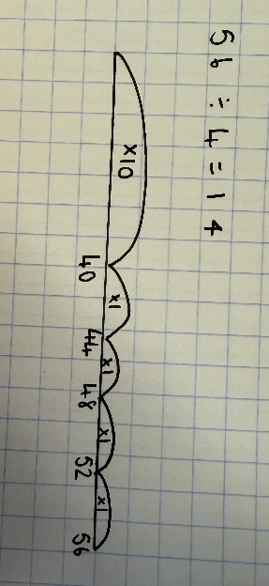  Use an empty number line – children draw a line and count on to work out how many groups of 4 there are in 52.  Note – always link to times tables knowledge – we should not need to draw a number line for 48 divided by 4 if we know our 4x tables.
Short division (bus stop)  Y4 – Divide a 2 or 3-digit number by a 1-digit number  Y5 – divide numbers up to 4 digits by a one-digit number using the formal written method of short division  Y6 – As Y5. | Use physical resources to represent calculations/problems.  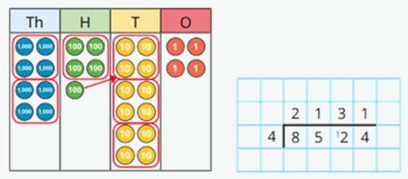  8524 ÷ 4 =  Example script  "We are dividing 8,524 by 4.  First, look at the thousands column. There are 8 thousands.  How many groups of 4 thousands can we make from 8 thousands?  We can make 2 groups of 4 thousands, so we write 2 above the thousands column.  Next, look at the hundreds column. There are 5 hundreds.  How many groups of 4 hundreds can we make from 5 hundreds?  We can make 1 group of 4 hundreds, so we write 1 above the hundreds column.  There is 1 hundred left over. We regroup that 1 hundred for 10 tens and move it to the tens column.  Now look at the tens column. We had 2 tens, and the regroupd 10 tens make 12 tens.  How many groups of 4 tens can we make from 12 tens?  We can make 3 groups of 4 tens, so we write 3 above the tens column.  There are no tens left over.  Now look at the ones column. There are 4 ones.  How many groups of 4 ones can we make from 4 ones?  We can make 1 group of 4 ones, so we write 1 above the ones column.  Therefore, 8,524 divided by 4 equals 2,131." | Move to giving children pictorial representations and then them drawing their own. These work alongside each other and the script remains the same.  8524 ÷ 4 = | Children will use the short division method to calculate.  8524 ÷ 4 =
Short division (bus stop)  Division with remainders  Y4 – Divide a 2 or 3-digit number by a 1-digit number  Y5 – divide numbers up to 4 digits by a one-digit number using the formal written method of short division and interpret remainders appropriately for the context | 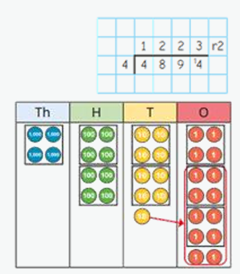  Use physical resources to represent  4894 ÷ 4 = | Draw dienes/PV counters  4894 ÷ 4 = | Children will use the short division method to calculate.  4894 ÷ 4 =
Divide decimals by integers  Y5/Y6 only | Physical PV counters to be used –  Mental method  Use – I know… so I also know.  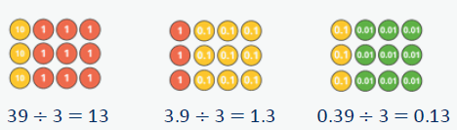  Use key knowledge – 3.9 is 39 divided by 10 so to work out 3.9 divided vy 3, we can do 39 divided by 3 and then divide our answer by 10.  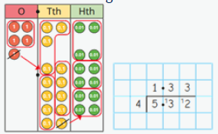  Written method | Draw and cross out PV counters alongside written method. | I know…  39 ÷ 3 = 13  so 3.9 ÷ 3 = 1.3  and 0.39 ÷ 3 = 13  Ensure that decimal remains lined up when dividing using a bus stop :
Long division  Before progressing to this method, children should have a solid understanding of and be able to use  - related facts, e.g. 3 4s is 12 so 3 40s is 120  - doubles  - halves  - subtraction |  | Children be well scaffolded with this method.  Step 1 – Paired/Group work with large squared paper and lists provided.  Step 2 – Create own list but still work in pairs to master the method.  Step 3 – Independently – lists given but method practised.  Step 4 – Independently – create own lists and practise method. | 1. Write the first 10 multiples of the divisor (bank of facts).  Use known facts to do 1x, 10x, halve it for 5x, do 2x, double it for 4x etc.  Where children struggle, make a list of 10s, a list of ones and recombine.  e.g.  1) 37  2) 74  3) 111  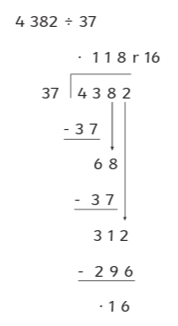  4) 148  5) 185  6) 222  7) 259  8) 296  9) 333  10) 370  2. Set out your bus stop method and use the following:  - Divide – See how many times the divisor fits into the first digit/two digits of the dividend.  - Multiply – Multiply the divisor by the quotient digit.  - Subtract – Subtract the result from the current number.  - Bring down – Bring down the next digit of the dividend.  - Repeat until all digits are used.

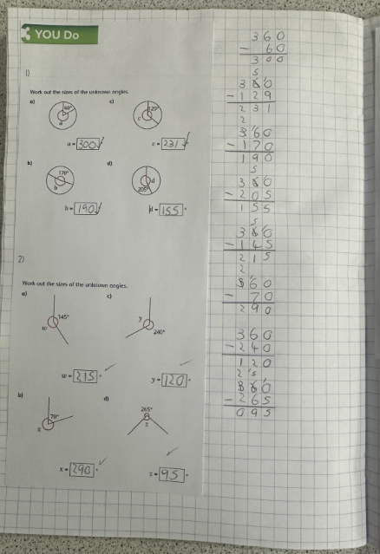
Presentation Expectations
We stick our Let’s review (previously Focus in 5) one full square across and one square under the learning objective.
We include a worked example on our Focus in 5 where applicable.
For working out, we do this to the right of the sheet or underneath (space dependent).
Answers can be written EITHER on the sheet in a provided space or to the right of the sheet.

We cross out errors using a ruler.

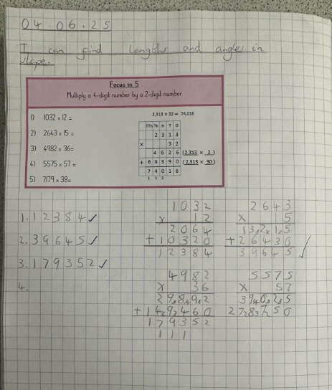
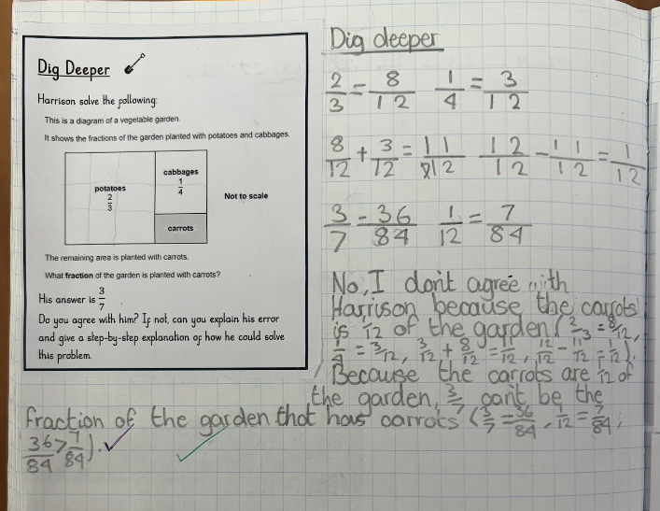
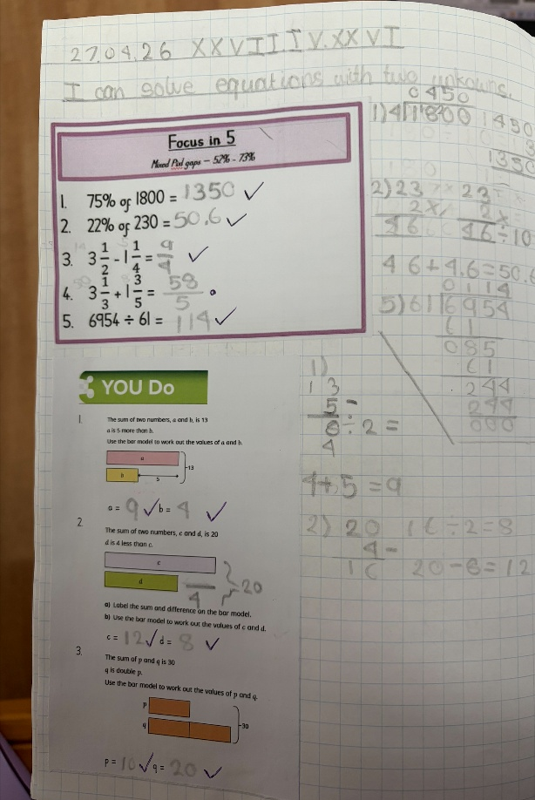
We fit our ‘You do’ sheet underneath our Focus in 5 if possible. This may need to be trimmed neatly with scissors.
We write one digit per square.
We stick our worksheet so that it lines up with the first full square.
For Dig Deeper tasks, we stick the sheet in and answer either to the right of it, or underneath (space dependent).
We stick our worksheet down the left-hand side and calculate/write our answers down the right-hand side.
Note – In Ks1, where working out is on a sheet with spaces provided e.g. drawing dienes into a given PV chart, a full-page sheet is acceptable.

