Executive Principal: Mrs C Barrington
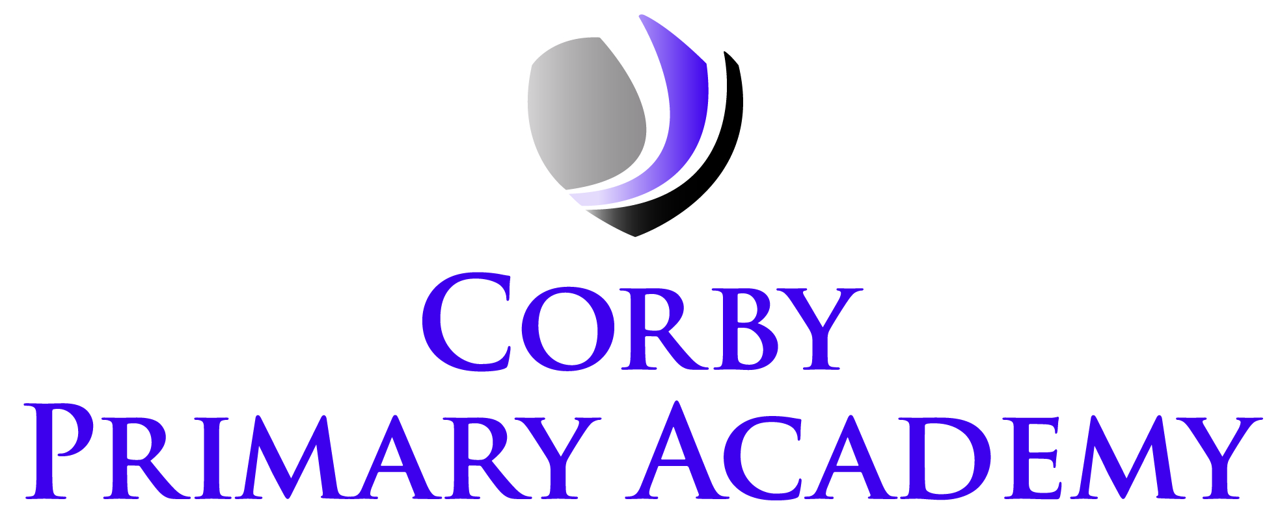

Butland Road, Corby, Northants NN18 8QA

Telephone: 01536 430510
Email: admin@corbyprimaryacademy.org
Website: www.corbyprimaryacademy.org
@CorbyPrimary

26 January 2023

Dear Parents and Carers,

Re: Industrial action

I hope this letter finds you well.

As you may be aware, the National Education Union (NEU) confirmed on Monday 16th January that its members will be striking over pay on four separate days in February and March. I am writing to reassure you about what this means and how it will impact your child.

Currently, strikes that will impact our academy are scheduled to take place on the below dates:

- Wednesday 1st February (whole country strike)
- Wednesday 1st March (East Midlands, West Midlands, Eastern)

- Wednesday 15th March (whole country strike)
- Thursday 16th March (whole country strike)

Striking is the right of every teacher who is part of a union and is a personal choice which we respect as an academy and Trust. As the academy’s Headteacher, it is my primary responsibility to ensure our pupils receive the highest standard of education and care. As such, please rest assured that we have comprehensive plans in place to ensure your child can continue their learning on those days with as minimal disruption as possible.

The safety and wellbeing of our pupils is our top priority. As our academy has a low number of staff who are members of the NEU, we will be able to keep the academy fully open and continue the school day as normal, ensuring there are alternative staffing arrangements in place for any staff who are on strike.

We will continue to communicate with you and keep you updated on the arrangements or any changes to the planned strike action.

Finally, I want to thank you for being so supportive as part of the school community in what has been a challenging period. If you have any questions, please do not hesitate to contact me at admin@corbyprimaryacademy.org.

Kind regards

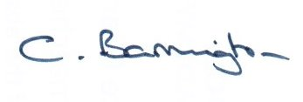
Mrs Chrissie Barrington
Executive Principal

